# Process to upload the energy utility data into our SQL server

The documentation explains the process to upload the energy utility data of neighborhood into Smart Grid Project Center team’s SQL server.

## Receiving data from Pecan Street

The data of the neighborhood is received from Pecan Street. Once the period for which the utility details are sought is finalized, an email needs to be sent to Grant P.Fisher from Pecan Street requesting the same. In the meantime, Susan A Nemier from the iSchool sends out a memory stick to Pecan Street. The memory stick is loaded with the data and sent back to us.

## Loading the data into the server

Once the memory stick is received, the data is copied into G:\IST\GET\ALL-DATA\CSV Version ALL-DATA folder.

Please follow the below steps to upload the data into the server.

1. Open the sql Server 2014 Management Studio application.
2. Right click on Pecan Street database and select Export Data.

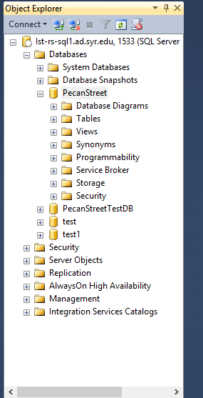

1. This opens the SQL Server Import and Export Wizard.

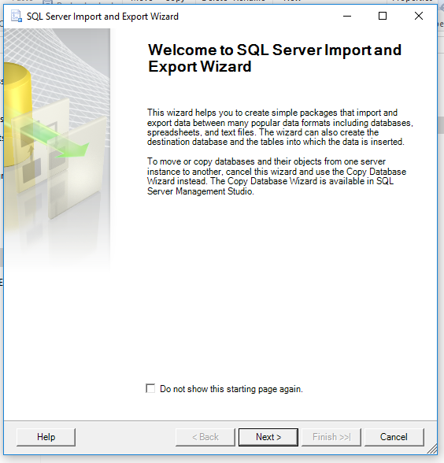

1. Select Next.
2. You will see the “Choose a Data Source” screen. ( This window allows you to choose the source from which you have to copy the data from)
3. Set the path of the data source in the “File name:” text box.
4. Select the check box “Column names in the first data row”.

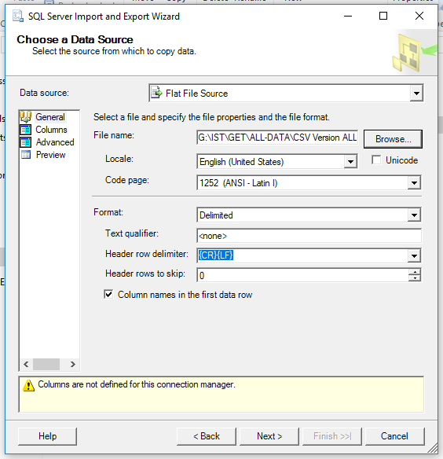

1. The options on the left pane under Data source allows you to explore the data.
2. Select “Advanced” option to see the details of the each column (such as Name, Data type).

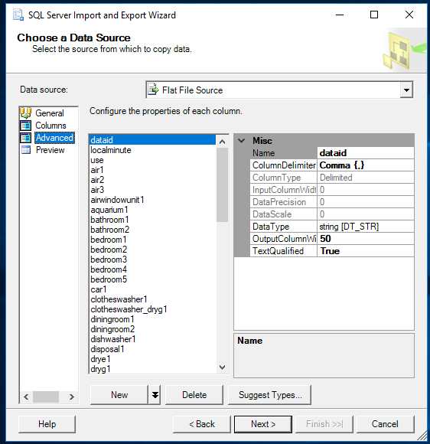

1. Select the “Preview” option to see a preview of the data.

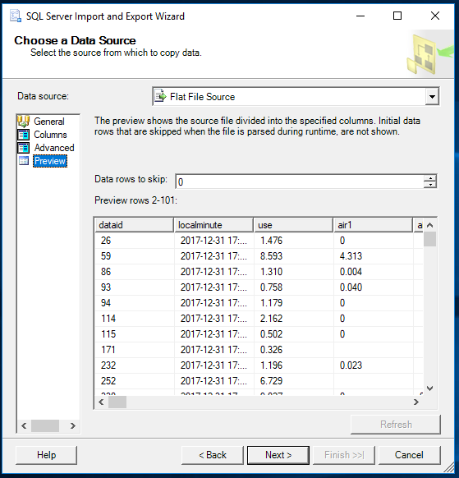

1. Select Next.
2. The wizard takes you to “Choose a Destination” screen.
3. Select the destination as “SQL Server Native Client 11.0”.
4. Usually the “Server name:” is set to “Ist-re-sql1.ad.syr.edu, 1553”, if not set the server name to the same.
5. Select the “Use Windows Authentication” radio button under “Authentication”.
6. Select the “Database” as Pecan Street.

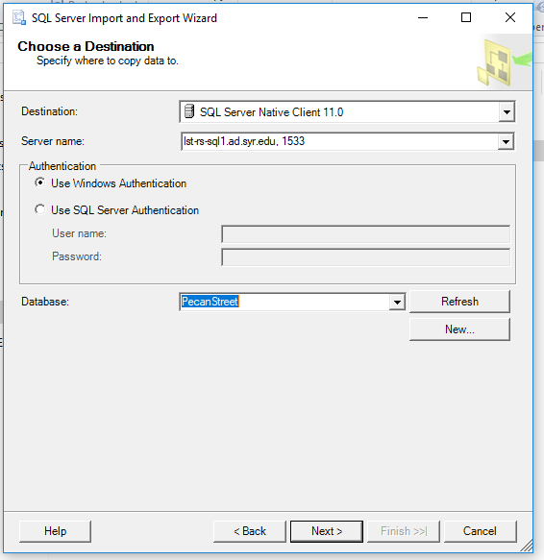

1. Select “Next”.
2. The “Select Source Tables and Views” screen allows you to choose the table in the database under which you need the data to be appended.
3. Select the table name under “Destination”.

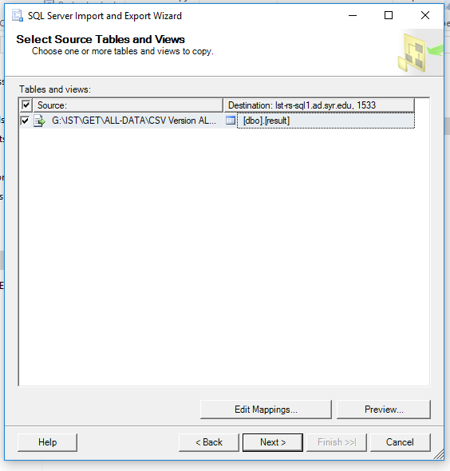

1. Select “Edit Mappings”.
2. This shows the “Column Mappings” screen. Here you will be able to see the source, destination, and option to perform different kinds operation in the table. Usually, “Append rows to the destination table” radio button is selected. Under the “Mappings” screen, you can see the source column names, destination column names, type of the column and size, etc.

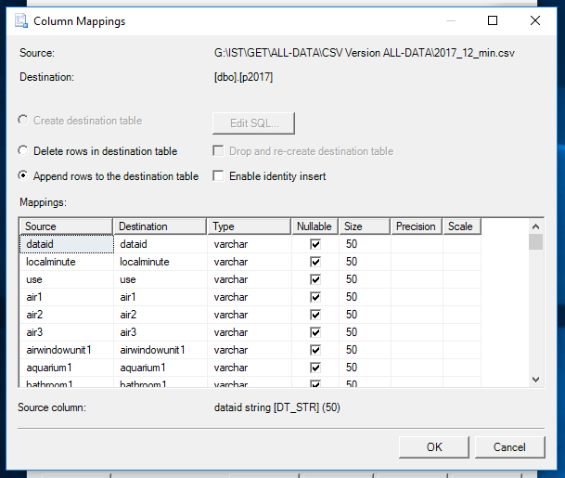

1. Select “OK”.
2. Select “Next”.
3. The “Save and Run Package” screen is displayed.
4. Usually you select the “Run immediately” check box and select “Next”.

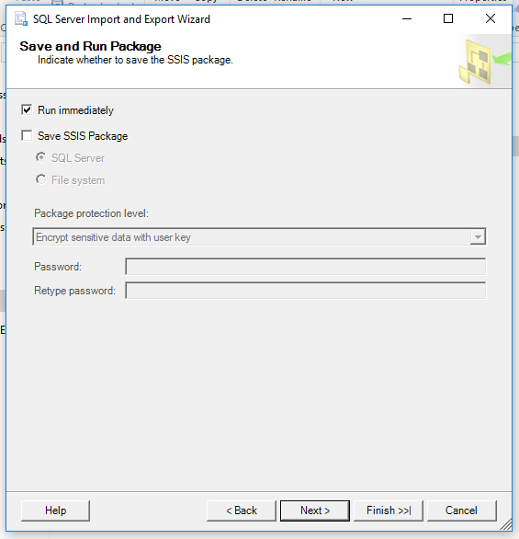

1. This takes you to the “Complete the Wizard” screen. Make sure all the details are correct in the screen. The source, the destination, and the kind of operation are displayed here.
2. Select “Finish”.

This copies all the data from local to the SQL server.